5. Next, reload the page a few times and check that the server returns the 304 Not Modified status instead of 200 ok:

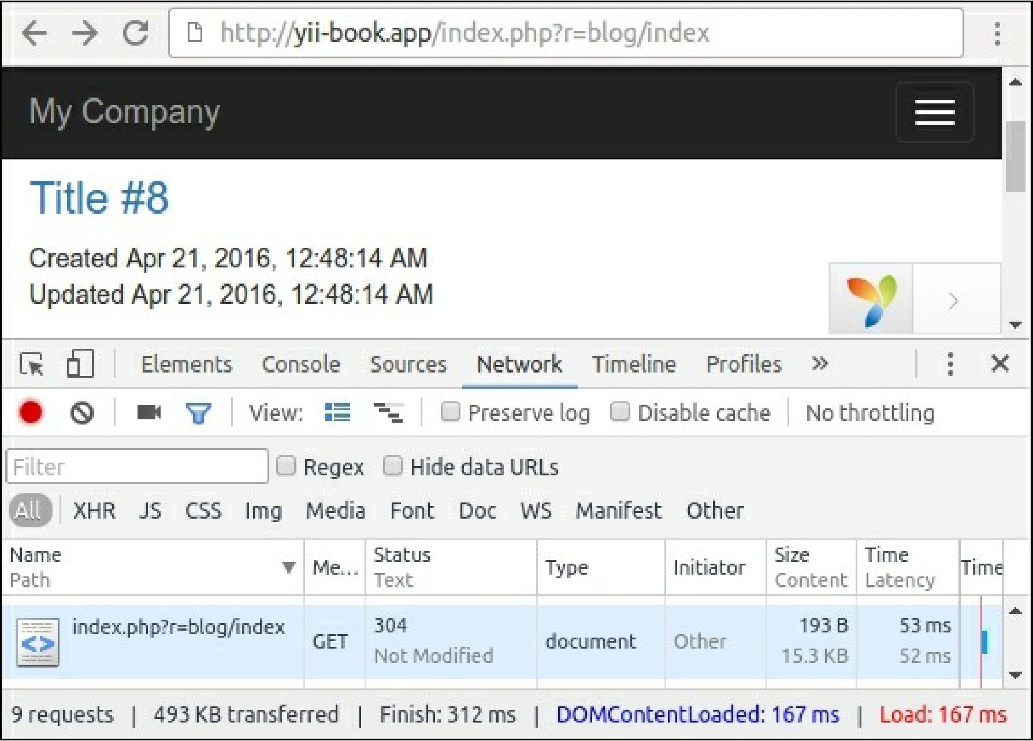

6. Open the relevant page using the following URL to update random articles: http: //yii- book.app/index.php?r=blog/update.

7. After updating the blog page, check that the server returns 200 ok the first time and 304 Not Modified thereafter, and verify that you see the new updated time on the page: